**NAME: Fatima jameel**

**Arid NO: 21-ARID-412**

**Section: 6A(Morning)**

**Submitted to: Sir Azhar**

**ASSIGHMENT#3**

**Implement menus including drawer OR tabs navigation**

Option Menu:

import android.os.Bundle;

import android.view.Menu;

import android.view.MenuItem;

import android.widget.Toast;

import androidx.annotation.NonNull;

import androidx.appcompat.app.AppCompatActivity;

public class MainActivity extends AppCompatActivity {

@Override

protected void onCreate(Bundle savedInstanceState) {

super.onCreate(savedInstanceState);

setContentView(R.layout.activity_main);

}

@Override

public boolean onCreateOptionsMenu(Menu menu) {

getMenuInflater().inflate(R.menu.menu_options, menu);

return true;

}

@Override

public boolean onOptionsItemSelected(@NonNull MenuItem item) {

switch (item.getItemId()) {

case R.id.action_settings:

// Handle settings action

Toast.makeText(this, "Settings clicked", Toast.LENGTH_SHORT).show();

return true;

case R.id.action_about:

// Handle about action

Toast.makeText(this, "About clicked", Toast.LENGTH_SHORT).show();

return true;

default:

return super.onOptionsItemSelected(item);

}

}

}

________________________________________________________________________________________________________

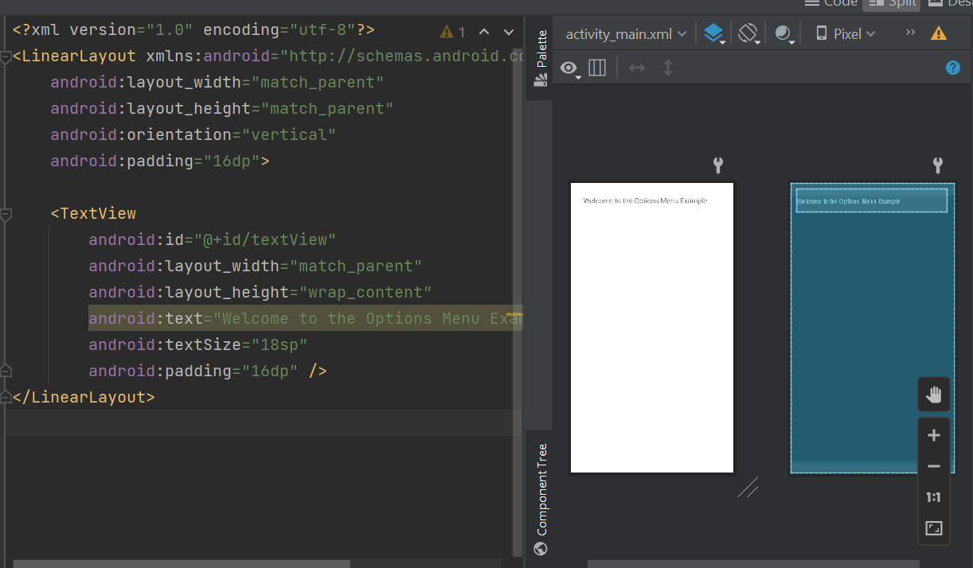

Context Menu:

import android.os.Bundle;

import android.view.ContextMenu;

import android.view.ContextMenu.ContextMenuInfo;

import android.view.MenuInflater;

import android.view.MenuItem;

import android.view.View;

import android.widget.AdapterView;

import android.widget.ArrayAdapter;

import android.widget.ListView;

import androidx.appcompat.app.AppCompatActivity;

public class MainActivity extends AppCompatActivity {

private ListView listView;

private String[] items = {"Item 1", "Item 2", "Item 3"};

@Override

protected void onCreate(Bundle savedInstanceState) {

super.onCreate(savedInstanceState);

setContentView(R.layout.activity_main)

listView = findViewById(R.id.listView);

ArrayAdapter<String> adapter = new ArrayAdapter<>(this,

android.R.layout.simple_list_item_1, items);

listView.setAdapter(adapter);

registerForContextMenu(listView);

}

@Override

public void onCreateContextMenu(ContextMenu menu, View v, ContextMenuInfo menuInfo) {

super.onCreateContextMenu(menu, v, menuInfo);

MenuInflater inflater = getMenuInflater();

inflater.inflate(R.menu.context_menu, menu);

}

@Override

public boolean onContextItemSelected(MenuItem item) {

AdapterView.AdapterContextMenuInfo info = (AdapterView.AdapterContextMenuInfo) item.getMenuInfo();

switch (item.getItemId()) {

case R.id.action_edit:

// Handle edit action

return true;

case R.id.action_delete:

// Handle delete action

return true;

default:

return super.onContextItemSelected(item);

}

}}

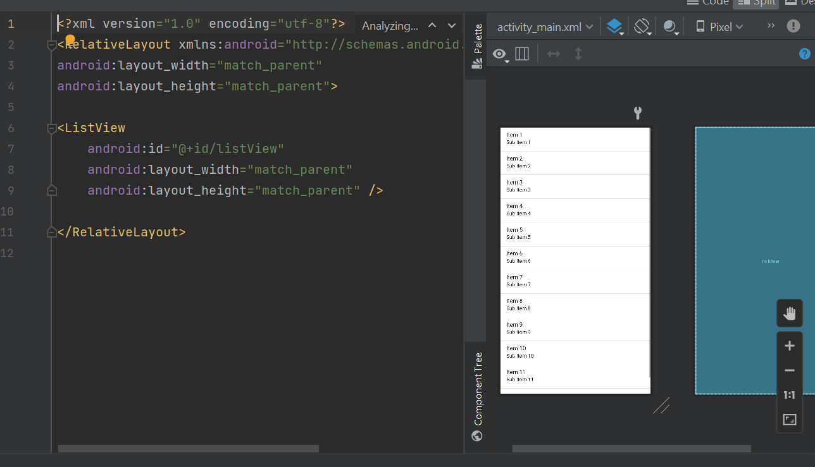

Popup Menu:

import android.os.Bundle;

import android.view.MenuInflater;

import android.view.MenuItem;

import android.view.View;

import android.widget.Button;

import android.widget.Toast;

import androidx.appcompat.app.AppCompatActivity;

import androidx.appcompat.widget.PopupMenu;

public class MainActivity extends AppCompatActivity {

private Button buttonShowPopup;

@Override

protected void onCreate(Bundle savedInstanceState) {

super.onCreate(savedInstanceState);

setContentView(R.layout.activity_main);

buttonShowPopup = findViewById(R.id.button_show_popup);

buttonShowPopup.setOnClickListener(new View.OnClickListener() {

@Override

public void onClick(View v) {

showPopupMenu(v);

}

});

}

private void showPopupMenu(View view) {

PopupMenu popupMenu = new PopupMenu(this, view);

MenuInflater inflater = popupMenu.getMenuInflater();

inflater.inflate(R.menu.popup_menu, popupMenu.getMenu())

popupMenu.setOnMenuItemClickListener(new PopupMenu.OnMenuItemClickListener() {

@Override

public boolean onMenuItemClick(MenuItem item) {

switch (item.getItemId()) {

case R.id.action_edit:

// Handle edit action

Toast.makeText(MainActivity.this, "Edit selected", Toast.LENGTH_SHORT).show();

return true;

case R.id.action_delete:

// Handle delete action

Toast.makeText(MainActivity.this, "Delete selected", Toast.LENGTH_SHORT).show();

return true;

default:

return false;

}

}

});

popupMenu.show();

}}

